dd
Front-End: React (JS/TS), Redux, React-native, AG Grid, React Query, HTML5, CSS3, Bootstrap, Material UI
UI/UX & Design: Figma, Photoshop, Illustrator, InDesign
Back-End & API: .NET Core (C#), RESTful APIs, Swagger, Serverless Microservices, AI agents, LLM applications, Prompt design, OpenAI APIs
DevOps & CI/CD: Git, GitHub Actions, Docker, Ubuntu, Bash, Azure
C# / .NET 6 | TypeScript | React | Node.js | Python | Java | SQL | PL/SQL | GraphQL | REST Microservices | Event-driven | Docker | Kubernetes | CI/CD | GitHub Actions | Terraform AWS | Azure | GCP | Serverless | Oracle DB | PostgreSQL | MongoDB | BigQuery | ETL Unit / Integration testing | TDD | Observability | Load balancing | Performance tuning Agile / Scrum | Kanban | JIRA | Domain-driven design | Pair-programming Software Engineer / Developer Full-stack Developer Backend Developer Front-end Developer Systems Developer DevOps / Cloud Engineer Agile Development
EXPERIENCES
Agentic Developer Intern
Sweden Startup Nation (SSN) - SISP, Sweden (Dec 2025 - Present)
- Agent-First Development: Collaborating with AI agents in coding, testing, deploying, and improving platform features.
- Data-Web Platform: Contributing across the stack from data models and APIs to modern UI and automation workflows for the Swedish Startup Nation Data Platform.
- Dashboards and Admin Tools: Supporting internal dashboards and admin tooling for ETL, monitoring, and data management
Full-Stack Developer & Systems Analyst
RADA Computing Solutions, Turin (Jun 2024 – Oct 2025)
Front-End Development & UI/UX:
- Led migration from a 2008 legacy system to a modern web platform using React (Vite.js), Redux, React Query, Material UI and AG Grid across 20+ modules
Built complex nested grids, implemented advanced filtering, and added multilingual support (i18n);
Full-Stack Developer & Systems Analyst
RADA Computing Solutions, Turin (Jun 2024 – Oct 2025)
Front-End Development & UI/UX:
- Led migration from a 2008 legacy system to a modern web platform using React (Vite.js), Redux, React Query, Material UI and AG Grid across 20+ modules
- Replaced PrimeReact tables with AG Grid to handle 150k+ manufacturing rows and reduced table load time by about 40 percent
B.A. Fine Arts,
Fine Arts Academy of Rome - GPA 4.0
B.Sc. Computer Science
Abrar University of Tehran - GPA 3.0
Coursework included C++, Java, Data analysis, Databases, HTML, CSS, Statistics, Networks, Mathematics
(+46) 765 761 526
Saeedeh.sarmadi89@gmail.com
LinkedIn: Saeedeh Asal Sarmadi
Gothenburg, Sweden
Saeedeh Sarmadi
Agentic Developer | Full-Stack Software Engineer | Front-End Specialist | UI/UX Enthusiast
EDUCATION
TECH STACK OVERVIEW

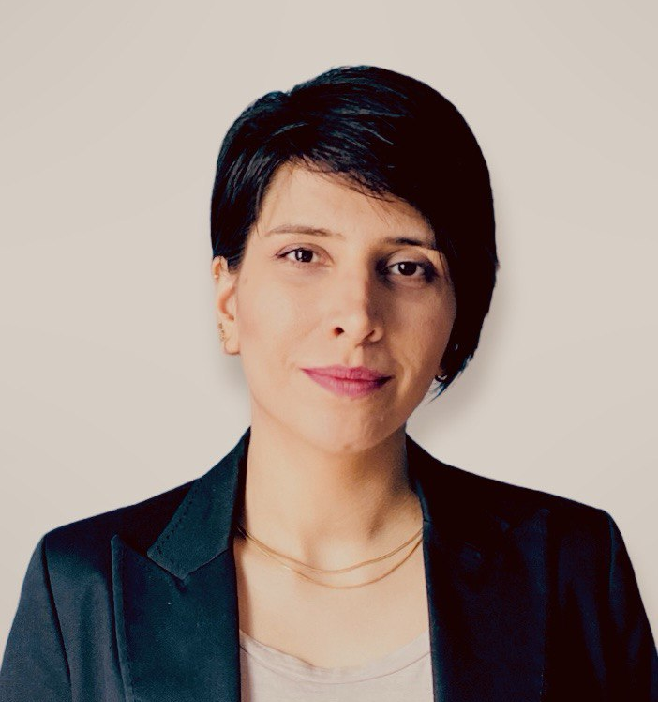

- Built complex nested grids, implemented advanced filtering, and added multilingual support (i18n); improved usability and performance with iterative UX improvements
- Designed and implemented .NET Core REST APIs; Documented endpoints with Swagger;
- integrated ASP.NET Identity and role-based authentication
- Developed and optimized Oracle PL/SQL packages, pipelined functions and stored procedures;
- Improved query execution time by 60 percent
- Delivered a GraphQL proof of concept that reduced client-side payload sizes by 30 percent and simplified data fetching
- Automated serverless workflows with AWS Lambda, API Gateway, Step Functions and S3; Lowered manual processing effort by about 50 percent
- Built an internal AI support chatbot in Python using OpenAI APIs; reduced repeat tickets and improved response time
Debugging & Optimization:
- Conducted comprehensive analysis and refactoring of legacy codebases, systematically resolving performance bottlenecks and addressing client-reported issues across various internal systems.
Front-End Development Intern
Liquido Studio, Turin (September 2023 - May 2024)

- Responsive Web Design: Developed user-friendly, responsive websites and web applications using HTML, CSS, WordPress and JavaScript, ensuring compatibility across various devices and platforms.
- WordPress Customization: Customized WordPress websites through theme modification, plugin integration, and content management, improving the site’s aesthetics and functionality.
- UI/UX Enhancements: Implemented UI/UX best practices to enhance the visual appeal and user experience of websites, leading to a measurable improvement in client satisfaction and engagement.

Earlier Experience (selected highlights)

- Software Engineer, DYS Company (Jan 2009 – Dec 2014) Co-developed an internal social-media platform, gathering cross-department requirements and delivering collaboration features that improved knowledge-sharing company-wide.
- Sales Consultant & Designer, Tanvarz – Tehran (Jan 2014 – Jun 2018) Designed multi-channel catalogs, banners, and e-books that lifted online engagement, and steered sales strategy through trend analysis and culturally localized content translations.

PROJECTS
Illustration & Workshop Series, Liberi di Crescere Association – Turin 2023 Led visual identity, promotional assets and on-site facilitation for a children’s-rights non-profit event.
Plastic Blue – Rome 2021–2022 Painting series and artistic studies exploring the impact of plastic pollution on nature and human life.
Women Life Freedom – Turin 2022 Led workshops and educational activities across multiple schools, engaging students in discussions and awareness on women's rights and freedom.

CERTIFICATIONS
IBM – Developing Front-End Apps with React
Engim Turin – Front-End Development (2023)
Google UX Design Program – Wireframes, Prototypes, Foundations & Design Thinking (2023)
LANGUAGE SKILLS
Persian (Mother tongue)
English (Advanced)
Italian (Advanced)
Swedish (beginner, actively studying)

